**Belarus Car Price Prediction**

The aim of this project is to predict the price of the car in Belarus, by analyzing the car features such as brand, year, engine, fuel type, transmission, mileage, drive unit, color, and segment. The project also aims to find out the set the of variables that has most impact on the car price.

The dataset has been taken from kaggle. It has 56244 rows and 12 columns.

# Data Dictionary

**Variable Description**

make machine firm

|  |  |
| --- | --- |
| model | machine model |
| price USD | price in USD (target variable) |
| year | year of production |
| condition | represents the condition at the sale moment (with mileage, for parts, etc) |
| mileage | mileage in kilometers |
| fuel type | type of the fuel (electro, petrol, diesel) |
| volume(cm3) | volume of the engine in cubic centimeters |
| color | color of the car |
| transmission | type of transmission |
| drive unit | drive unit |
| segment | segment of the car |

|  |
| --- |
| *# Loading the libraries* **import** pandas **as** pd **import** numpy **as** np **import** matplotlib.pyplot **as** plt **import** seaborn **as** sns |

In [ ]:

|  |
| --- |
| *# Loading the dataset* df **=** pd**.**read_csv('cars.csv') df**.**head() |

In [ ]:

Out[ ]: **make model priceUSD year condition mileage(kilometers) fuel_type volume(cm**

with

**0** mazda 2 5500 2008 162000.0 petrol 150 mileage

|  |  |  |  |  |  |  |  |  |
| --- | --- | --- | --- | --- | --- | --- | --- | --- |
| **1** | mazda | 2 | 5350 | 2009 | with mileage | 120000.0 | petrol |  |
| **2** | mazda | 2 | 7000 | 2009 | with mileage | 61000.0 | petrol |  |
| **3** | mazda | 2 | 3300 | 2003 | with mileage | 265000.0 | diesel |  |
| **4** | mazda | 2 | 5200 | 2008 | with mileage | 97183.0 | diesel |  |

130

150

140

140

# Data Preprocessing Part 1

In [ ]: *# Checking the shape of the dataset* df**.**shape

|  |  |
| --- | --- |
| Out[ ]: | (56244, 12) |

In [ ]: *# Checking the data types of the columns* df**.**dtypes

Out[ ]: make object model object priceUSD int64 year int64 condition object mileage(kilometers) float64 fuel_type object volume(cm3) float64 color object transmission object drive_unit object segment object dtype: object

In [ ]: *# Droping the columns that are not needed for the analysis* df**.**drop(columns **=** ['model','segment'], inplace**=True**)

In [ ]: *# Unique values in the columns* df**.**nunique()

Out[ ]: make 96 priceUSD 2970 year 78 condition 3 mileage(kilometers) 8400 fuel_type 3 volume(cm3) 458 color 13

transmission 2 drive_unit 4 dtype: int64

In [ ]: *# Unqiue car make* df['make']**.**unique()

Out[ ]: array(['mazda', 'mg', 'renault', 'gaz', 'aro', 'rover', 'uaz',

'alfa-romeo', 'audi', 'oldsmobile', 'saab', 'peugeot', 'chrysler',

'wartburg', 'moskvich', 'volvo', 'fiat', 'roewe', 'porsche', 'zaz',

'luaz', 'dacia', 'lada-vaz', 'izh', 'raf', 'bogdan', 'bmw',

'nissan', 'mercedes-benz', 'mitsubishi', 'toyota', 'chery', 'gmc',

'hyundai', 'honda', 'ssangyong', 'suzuki', 'opel', 'seat',

'volkswagen', 'daihatsu', 'chevrolet', 'geely', 'saturn', 'kia',

'lincoln', 'eksklyuziv', 'citroen', 'dong-feng', 'pontiac', 'ford',

'subaru', 'bentley', 'faw', 'cadillac', 'lifan', 'plymouth',

'hafei', 'shanghai-maple', 'mini', 'jeep', 'skoda', 'mercury',

'changan', 'lexus', 'isuzu', 'aston-martin', 'lancia',

'great-wall', 'land-rover', 'jaguar', 'buick', 'daewoo', 'vortex',

'infiniti', 'byd', 'smart', 'maserati', 'haval', 'acura', 'scion',

'tata', 'datsun', 'tesla', 'mclaren', 'ravon', 'trabant', 'proton', 'fso', 'jac', 'asia', 'iran-khodro', 'zotye', 'tagaz', 'saipa', 'brilliance'], dtype=object)

Since there are you many car make, and it is difficult to analyze them individually, so I will group them into categories : Luxury European, Mainstream European, Russina/ Eastern European, Asian, American, Speciality, and Other. The grouping is based on the car make and the country of origin.

In [ ]:

|  |
| --- |
| *# Categorizing the car make* **def** car_make(make):  **if** make **in** ['mazda', 'mg', 'rover','alfa-romeo', 'audi', 'peugeot', 'chrysle **return** 'Luxury European' **elif** make **in** ['renault','dacia', 'citroen', 'volvo', 'fiat', 'opel', 'seat' **return** 'Mainstream European' **elif** make **in** ['gaz', 'aro', 'lada-vaz', 'izh', 'raf', 'bogdan', 'moskvich', **return** 'Russian/Eastern European' **elif** make **in** ['toyota', 'nissan','asia', 'mitsubishi', 'chery', 'hyundai', **return** 'Asian' **elif** make **in** ['oldsmobile', 'gmc', 'chrysler', 'plymouth', 'ford', 'cadillac **return** 'American' **elif** make **in** ['porsche','bentley', 'maserati', 'tesla', 'mclaren']:  **return** 'Specialty' **else**:  **return** 'Other'    df['make_segment'] **=** df['make']**.**apply(car_make) |

,

'

Descriptive statistics

|  |
| --- |
| df**.**describe() |

In [ ]:

Out[ ]: **priceUSD year mileage(kilometers) volume(cm3)**

**count** 56244.000000 56244.000000 5.624400e+04 56197.000000

|  |  |  |  |  |
| --- | --- | --- | --- | --- |
| **mean** | 7415.456440 | 2003.454840 | 2.443956e+05 | 2104.860615 |
| **std** | 8316.959261 | 8.144247 | 3.210307e+05 | 959.201633 |
| **min** | 48.000000 | 1910.000000 | 0.000000e+00 | 500.000000 |
| **25%** | 2350.000000 | 1998.000000 | 1.370000e+05 | 1600.000000 |
| **50%** | 5350.000000 | 2004.000000 | 2.285000e+05 | 1996.000000 |
| **75%** | 9807.500000 | 2010.000000 | 3.100000e+05 | 2300.000000 |
| **max** | 235235.000000 | 2019.000000 | 9.999999e+06 | 20000.000000 |

|  |  |  |  |  |  |
| --- | --- | --- | --- | --- | --- |
| df**.**head() |  |  |  |  |  |
| **make priceUSD** | **year** | **condition** | **mileage(kilometers)** | **fuel_type** | **volume(cm3)** |

In [ ]:

Out[ ]:

with

**0** mazda 5500 2008 162000.0 petrol 1500.0 bur mileage

|  |  |  |  |  |  |  |  |  |
| --- | --- | --- | --- | --- | --- | --- | --- | --- |
| **1** | mazda | 5350 | 2009 | with mileage |  | 120000.0 | petrol | 1300.0 |
| **2** | mazda | 7000 | 2009 | with mileage |  | 61000.0 | petrol | 1500.0 |
| **3** | mazda | 3300 | 2003 | with mileage |  | 265000.0 | diesel | 1400.0 |
| **4** | mazda | 5200 | 2008 | with mileage |  | 97183.0 | diesel | 1400.0 |

# Exploratory Data Analysis

In the exploratory data analysis, I will analyze the relationship between the target variable and the independent variables. I will also analyze the relationship between the independent variables. This will help me to understand the data better and to find out the variables that have most impact on the target variable.

## Car Make Segment

|  |
| --- |
| sns**.**barplot(x**=**df['make_segment']**.**unique(), y**=**df['make_segment']**.**value_counts(), plt**.**xticks(rotation**=**90) |

In [ ]:

Out[ ]: (array([0, 1, 2, 3, 4, 5, 6]),

[Text(0, 0, 'Luxury European'),

Text(1, 0, 'Mainstream European'),

Text(2, 0, 'Russian/Eastern European'),

Text(3, 0, 'American'),

Text(4, 0, 'Other'),

Text(5, 0, 'Specialty'),

Text(6, 0, 'Asian')])

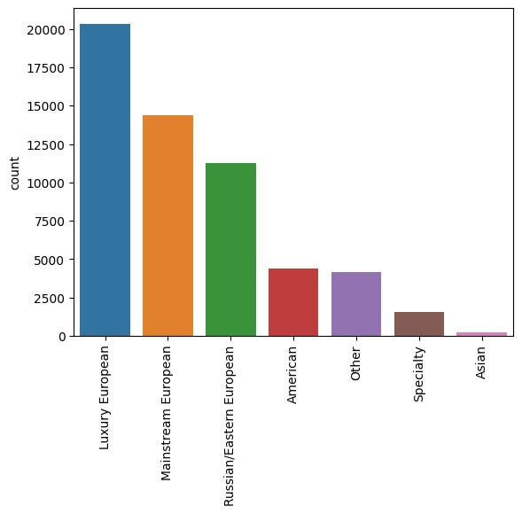

In the dataset, most of the cars are european (particulary majority of the are Luxury followed by Mainstream and Russian/Eastern European). However the dataset also has american as well asian cars. There are also some speciality cars such as Tesla, McLaren, Bentley, etc. The dataset also has some cars that are not categorized into any of the above categories.

## Categorical Variable Distribution

|  |
| --- |
| fig, ax **=** plt**.**subplots(2,3,figsize**=**(20,10)) sns**.**countplot(x**=**'condition', data**=**df, ax**=**ax[0,0]) sns**.**countplot(x**=**'fuel_type', data**=**df, ax**=**ax[0,1]) sns**.**countplot(x**=**'transmission', data**=**df, ax**=**ax[0,2]) sns**.**countplot(x**=**'color', data**=**df, ax**=**ax[1,0]) ax[1,0]**.**tick_params(axis**=**'x', rotation**=**90) |

In [ ]:

sns**.**countplot(x**=**'drive_unit', data**=**df, ax**=**ax[1,1]) ax[1,1]**.**tick_params(axis**=**'x', rotation**=**90) sns**.**countplot(x**=**'make_segment', data**=**df, ax**=**ax[1,2]) ax[1,2]**.**tick_params(axis**=**'x', rotation**=**90)

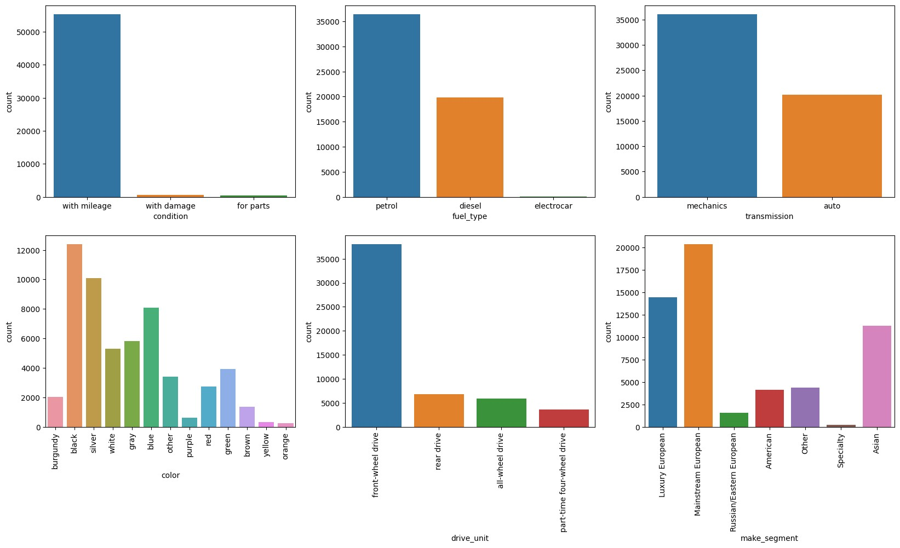

From the above graphs, we can get an overview regarding the data across the categorical variables in the data set. The from the above graphs it is clear that majority of the cars are being sold are in working condition, majority of them run on petrol, followed by diesel and hardly any of them runs on electricity. Most of the cars have manual transmission, with front wheel drive, having colors such as balck, silver, blue, white, and

grey.

## Continuous Variable Distribution

In [ ]: fig, ax **=** plt**.**subplots(2,2,figsize**=**(20,10)) sns**.**histplot (df['year'], ax**=**ax[0,0], bins **=** 50) sns**.**histplot(df['priceUSD'], ax**=**ax[0,1]) sns**.**histplot(df['mileage(kilometers)'], ax**=**ax[1,0], bins **=** 100) sns**.**histplot(df['volume(cm3)'], ax**=**ax[1,1], bins **=** 100)

Out[ ]: <Axes: xlabel='volume(cm3)', ylabel='Count'>

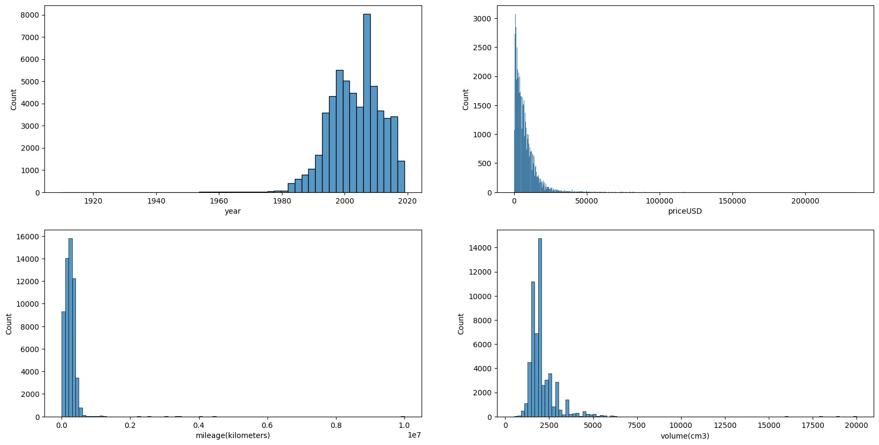

The above graphs shows the distribution of the data across continuous variables. Majority of the cars are manufactured between 1990 to 2019,having price less than 50k USD, mileage less than 1 million km, engine volume between 1750 to 2000 cm3.

Since most of the cars are manufactured after 1980, so I will only consider the cars manufactured after 1980.

In [ ]: df**=** df[df['year']**>**1980]

## Price and Make

|  |
| --- |
| demodf **=** df**.**groupby('make')['priceUSD']**.**mean()**.**reset_index() demodf **=** demodf**.**sort_values(by**=**'priceUSD', ascending**=False**)**.**head(10)  *#b Bar Plot*  plt**.**figure(figsize**=**(8,5)) sns**.**barplot(y**=**'make', x**=**'priceUSD', data**=**demodf) plt**.**xticks(rotation**=**90) plt**.**title('Top 10 Most Expensive Car Brands') plt**.**ylabel('Car Brand') plt**.**xlabel('Price in USD') plt**.**show() |

In [ ]:

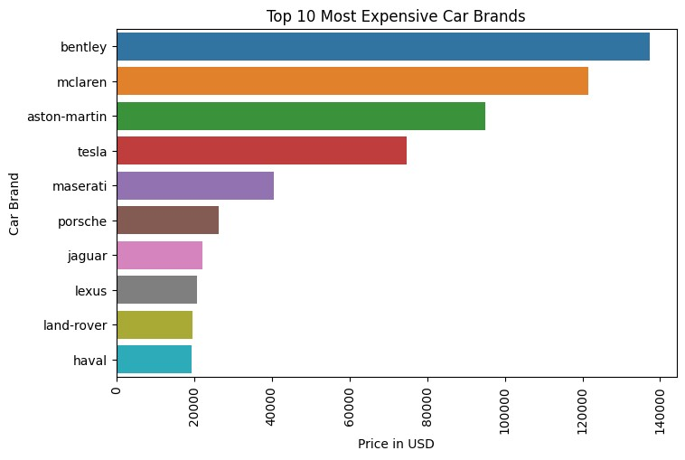

This graph shows top 10 most expensive car brands in the data set. The top 5 most expensive car brands are Bentley, Mclaren, aston-martin, Tesla and meserati.

## Price and Condition

|  |
| --- |
| sns**.**lineplot(x **=** 'year', y **=** 'priceUSD', data **=** df, hue **=** 'condition') plt**.**title('Price of Cars by Year and Condition') plt**.**show() |

In [ ]:

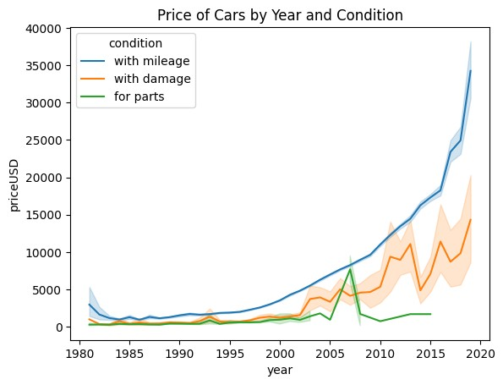

This graph shows the relationship between the price and the year of the car along with selling codition of the car. Cars, which are sold in working condition, are more expensive and their price increased with time, having exponential increase between 2015 to 2020. Cars, which were damaged, had a similar price to tha cars which were sold for parts between 1980 to 2000. However, the price of the damaged cars increased significanlty after 2000. Cars, which were sold for parts, tend to have minimal price and their price increased very little with time.

The cars running on petrol and diesel have similar mileage, however their prices are quite different. The cars running on petrol tend to have higher price than the diesel ones. The cars running on electricity tend to have very high prices and low mileage.

## Price and Transmission

|  |
| --- |
| sns**.**lineplot(x **=** 'year', y **=** 'priceUSD', data **=** df, hue **=** 'transmission') plt**.**title('Price of Cars and Transmission') plt**.**show() |

In [ ]:

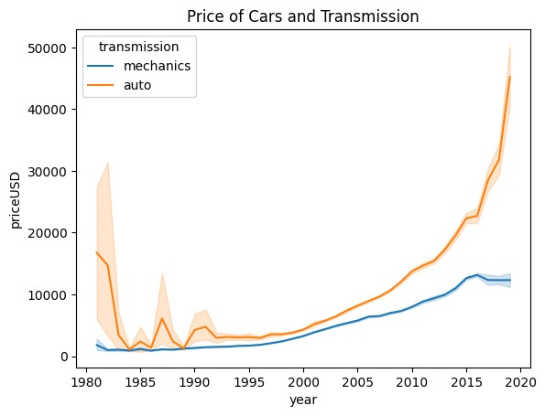

This graph reveals the changes in the car price based on their transmission. The price of the cars with automatic transmission decreased significantly after 1983, however its price increased exponentially after 2000. However, the price of the cars with manual transmission is always less than the cars with automatic transmission showing similar increase in price after 2000.

## Price and Fuel Type

|  |
| --- |
| sns**.**lineplot(x **=** 'year', y **=** 'priceUSD', data **=** df, hue **=** 'fuel_type') plt**.**title('Price of Cars and Fuel Type') plt**.**show() |

In [ ]:

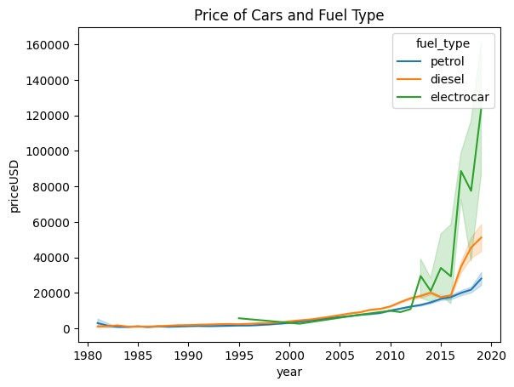

Till 2005, there was no major difference in car price of cars running on petrol and diesel. However, after 2015, the price of the cars running on petrol increased significantly, whereas the price of the cars running on diesel increased with a very small margin. The graph also highloghts the introducttion of electro cars, which runs on electricity in 1995. However, the price of the electro cars increases exponentially after 2015, having the highest car price based on fuel type

## Price and Drive Unit

|  |
| --- |
| sns**.**lineplot(x **=** 'year', y **=** 'priceUSD', data **=** df, hue **=** 'drive_unit') plt**.**title('Price of Cars and Drive Unit') plt**.**show() |

In [ ]:

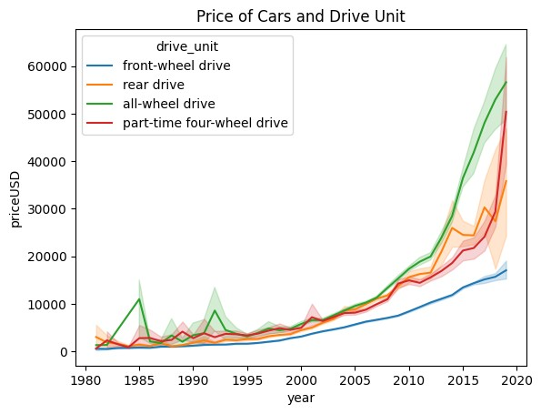

Between 1980 to 1995, there was not much difference in the price of the cars based on the drive unit. However after 1995, the price of the cars with front wheel drive increased at a slower pace as compared to other drive units. The price of the cats with all wheel drive increased significantly after 2005, having the highest price among all the drive units, followed by part-time four wheel drive and rear wheel drive.

## Price and Brand Segment

|  |
| --- |
| sns**.**lineplot(x **=** 'year', y **=** 'priceUSD', data **=** df, hue **=** 'make_segment') plt**.**title('Price of Cars and Brand Segment') plt**.**show() |

In [ ]:

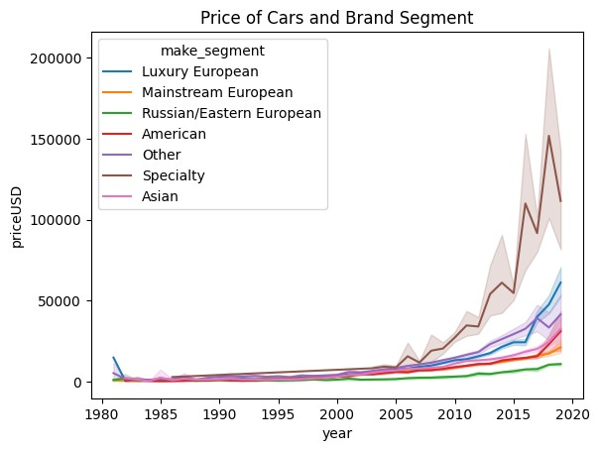

This graph shows the surge in car prices after 2005, where we can seen that the price of the specialty car segment increased significanlty followed by the luxury european car, American, Asian and Mainstream European car segment. The price of the Russian/Eastern European car segment increased at a slower pace as compared to other segments and is lowest among all the segments.

# Data Preprocessing Part 2

In [ ]: *# checking for null values* df**.**isnull()**.**sum()

Out[ ]: make 0 priceUSD 0 year 0 condition 0 mileage(kilometers) 0 fuel_type 0 volume(cm3) 47 color 0 transmission 0 drive_unit 1874 make_segment 0 dtype: int64

Since, the count of null values in small in comparison to that dataset size, I will be dropping the null values from the dataset.

In [ ]: df**.**dropna(inplace**=True**)

|  |
| --- |
| df**.**drop(columns**=**['make'], inplace**=True**) |

In [ ]:

## Label encoding for object data type

|  |
| --- |
| **from** sklearn.preprocessing **import** LabelEncoder  *# columns to encode*  cols **=** ['condition', 'fuel_type', 'transmission', 'color', 'drive_unit', 'make_s  *# Label encoding Object* le **=** LabelEncoder()  *#label encoding for each column* **for** col **in** cols: le**.**fit(df[col]) df[col] **=** le**.**transform(df[col]) print(col, df[col]**.**unique()) |

In [ ]:

condition [2 1 0] fuel_type [1 0] transmission [1 0] color [ 3 0 10 11 4 1 7 8 9 5 2 12 6] drive_unit [1 3 0 2] make_segment [2 3 5 0 4 6 1]

# Correlation Matrix Heatmap

|  |
| --- |
| plt**.**figure(figsize**=**(10,10))  sns**.**heatmap(df**.**corr(), annot**=True**, cmap**=**'coolwarm') |

In [ ]:

Out[ ]: <Axes: >

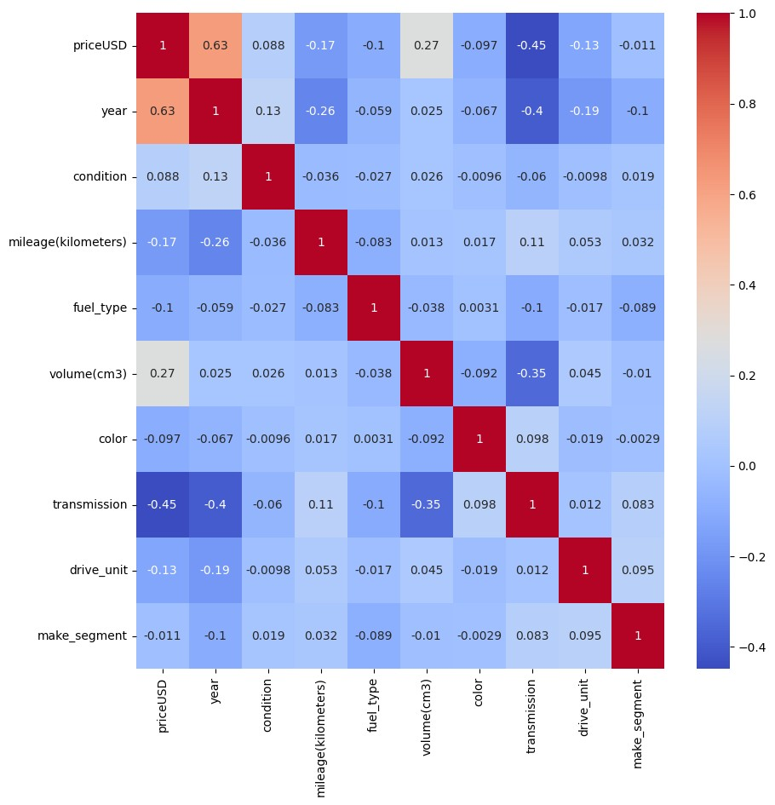

# Outlier Removal

|  |
| --- |
| *# Using Z-score to remove outliers* **from** scipy **import** stats z **=** np**.**abs(stats**.**zscore(df)) threshold **=** 3  *#columns with outliers*  cols **=** ['year', 'mileage(kilometers)', 'volume(cm3)']  *#removing outliers* df **=** df[(z **<** 3)**.**all(axis**=**1)] |

In [ ]:

# Train Test Split

|  |
| --- |
| **from** sklearn.model_selection **import** train_test_split  X_train, X_test, y_train, y_test **=** train_test_split(df**.**drop(columns**=**['priceUSD' |

In [ ]:

]

# Model Building

## Decision Tree Regressor

|  |
| --- |
| **from** sklearn.tree **import** DecisionTreeRegressor  *# Decision Tree Regressor Object* dtr **=** DecisionTreeRegressor() |

In [ ]:

### Hypertuning using GridSearchCV

|  |
| --- |
| **from** sklearn.model_selection **import** GridSearchCV  *#parameters for grid search* params **=** {  'max_depth': [2,4,6,8],  'min_samples_split': [2,4,6,8],  'min_samples_leaf': [1,2,3,4],  'max_features': ['auto', 'sqrt', 'log2'],  'random_state': [0,42]  }  *# Grid Search Object*  grid **=** GridSearchCV(dtr, param_grid**=**params, cv**=**5, verbose**=**1, n_jobs**=-**1)  *#fitting the grid search* grid**.**fit(X_train, y_train)  *#best parameters* print(grid**.**best_params_) |

In [ ]:

Fitting 5 folds for each of 384 candidates, totalling 1920 fits

{'max_depth': 8, 'max_features': 'auto', 'min_samples_leaf': 4, 'min_samples_spli t': 2, 'random_state': 0}

C:\Users\DELL\AppData\Local\Packages\PythonSoftwareFoundation.Python.3.11_qbz5n2k fra8p0\LocalCache\local-packages\Python311\site-packages\sklearn\tree\_classes.p y:277: FutureWarning: `max_features='auto'` has been deprecated in 1.1 and will b e removed in 1.3. To keep the past behaviour, explicitly set `max_features=1.0'`. warnings.warn(

In [ ]:

|  |
| --- |
| *#decision tree regressor with best parameters*  dtr **=** DecisionTreeRegressor(max_depth**=**8, max_features**=**'auto', min_samples_leaf**=**  *#fitting the model* dtr**.**fit(X_train, y_train) |

4

C:\Users\DELL\AppData\Local\Packages\PythonSoftwareFoundation.Python.3.11_qbz5n2k fra8p0\LocalCache\local-packages\Python311\site-packages\sklearn\tree\_classes.p y:277: FutureWarning: `max_features='auto'` has been deprecated in 1.1 and will b e removed in 1.3. To keep the past behaviour, explicitly set `max_features=1.0'`.

warnings.warn(

Out[ ]: 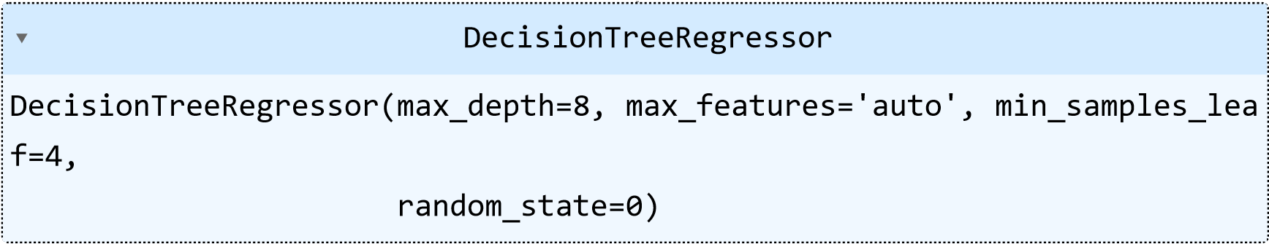

In [ ]: *#training score* dtr**.**score(X_train, y_train)

|  |  |
| --- | --- |
| Out[ ]: | 0.8689232243678456 |

In [ ]: *#predicting the test set*

y_pred **=** dtr**.**predict(X_test)

# Model Evaluation

In [ ]: **from** sklearn.metrics **import** r2_score, mean_squared_error, mean_absolute_error print('R2 Score: ', r2_score(y_test, y_pred)) print('Mean Squared Error: ', mean_squared_error(y_test, y_pred)) print('Mean Absolute Error: ', mean_absolute_error(y_test, y_pred)) print('Root Mean Squared Error: ', np**.**sqrt(mean_squared_error(y_test, y_pred)))

R2 Score: 0.8529954473045238

Mean Squared Error: 4704555.776616746

Mean Absolute Error: 1414.2804910704947 Root Mean Squared Error: 2168.9987959002524

# Feature Importance

|  |
| --- |
| feat_df **=** pd**.**DataFrame({'Feature': X_train**.**columns, 'Importance': dtr**.**feature_im feat_df **=** feat_df**.**sort_values(by**=**'Importance', ascending**=False**) feat_df |

In [ ]:

Out[ ]: **Feature Importance**

**0** year 0.754301

|  |  |  |
| --- | --- | --- |
| **4** | volume(cm3) | 0.200413 |
| **3** | fuel_type | 0.017333 |
| **6** | transmission | 0.010267 |
| **8** | make_segment | 0.009639 |
| **7** | drive_unit | 0.006883 |
| **2** | mileage(kilometers) | 0.000872 |
| **5** | color | 0.000292 |
| **1** | condition | 0.000000 |

|  |
| --- |
| *# Bar Plot*  sns**.**set_style('darkgrid') plt**.**figure(figsize**=**(8,5)) |

In [ ]:

sns**.**barplot(x**=**'Importance', y**=**'Feature', data**=**feat_df) plt**.**title('Feature Importance') plt**.**show()

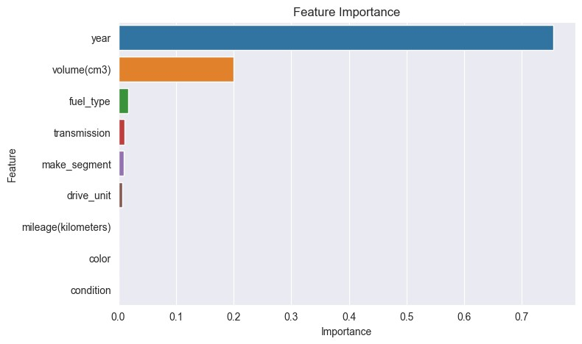

# Conclusion

The aim of this project was to predict the price of the car in Belarus, by analyzing the car features such as brand, year, engine, fuel type, transmission, mileage, drive unit, color, and segment. During the exploratory data analysis, it was found that there has been a significant increase in car prices in Belarus after the year 2000. The cars which runs on petrol have automatic transmission have higher price has compared to diesel cars with manual transmission. However, the elctric cars are distinctively expensive than the other cars. The cars with all wheel drive have the highest price among all the drive units. The speciality segment cars have the highest price among all the segments followed by luxury european, american, asian car segments.

The decision tree regressor model was used to predict the car price. The model was able to predict the car price with 85.29% accuracy. The most important features for predicting the car price were found to be year and volume of the engine.